**Practical 12  
Users and Groups**

1. Local Linux Users configuration
2. Examining User Information
3. User Administration
4. Group Administration

# Read more: [User Management at ubuntu help](https://help.ubuntu.com/lts/serverguide/user-management.html.en)

|  |
| --- |
| useradd userdelete  System administrators create user accounts to allow access to the system or system services. To add a new user, you will use the useradd command.  useradd -u User_ID -g Group [-d Directory_Path] [-m] [-c "Full_User_Name"] User_Name  userdel -r User_Name (The -r parameter removes the user's home directory and mail spool file if they exist.)  groupadd groupdelete Groups allow system administrators to apply certain permissions or access to groups of users. Groups must be created first before you can assign a user to that group. To add a new group, you will use the groupadd command. Syntax  groupadd -g Group_ID Group_Name groupdel Group_Name |

# 

## Create a Group

## The following steps will guide you through creating a group on an Ubuntu Linux Server system.

## To begin adding a new group to your system, you will need to be logged in using a valid user account.

## We will add a new group with a Group ID of 10000 and a Group Name of students. To add the group called students, we would enter the following command: sudo groupadd -g 10000 students When you have entered the command, press the Enter key to execute the command.

## If all goes well, you will see the system prompt appear again without any errors. This indicates that the new group called students has been added successfully.

## In this step we will check to ensure that the group called students was added to the system. Since new groups are added to the end of the system group file called /etc/group, we can use the [tail command](https://www.techonthenet.com/linux/commands/tail.php) to verify that the new group was added. Enter the following [tail command](https://www.techonthenet.com/linux/commands/tail.php) after the system prompt to show the last few lines of the system group file: sudo tail /etc/group

## As seen in the screenshot below, the following line appears at the end of the /etc/group file indicating that the students group was created. students:x:10000:

## 

## Congratulations, you have successfully added a new group to your Ubuntu Linux Server system!

## Create a User

The following steps will guide you through creating a user on an Ubuntu Linux Server system.

1. To begin adding a new user to your system, you will need to be logged in using a valid user account for your system. If you are unsure of how to do this, read our tutorial on [Logging into Ubuntu Linux Server](https://www.techonthenet.com/linux/sysadmin/ubuntu/login_14_04.php).
2. We will add a new user called **jsmith** which has a User ID of **10000**, a home directory of **/home/jsmith** and is a member of the group called **students** which has a Group ID of **10000**.  
   To add the user called **jsmith**, we would enter the following command:  
     
   sudo useradd -u 10000 -g 10000 -m -c "Jim Smith" jsmith

adduser (user) (user id and group id auto set) to make /bin/bash

|  |
| --- |
| option ___-m___ (create)is to create the user's home directory if it does not exist.  option ___-c__ (comment) is used to give a short description of the login, and is currently  used as the field for the user's full name.  reference: <http://manpages.ubuntu.com/manpages/bionic/man8/useradd.8.html> |

1. The **sudo** command will now prompt you to enter the password for your administrator account.  
     
   *Please note that no characters will show as you type your password. This is normal and is important to preserve the security of your password.*After you have entered your password, press the Enter key to continue.
2. If all goes well, you will see the system prompt appear again without any errors. This indicates that the new user called **jsmith** has been added successfully.
3. In this step we will check to ensure that the new user called **jsmith** was added to the system. Since new users are added to the end of the system passwd file called **/etc/passwd**, we can use the [tail command](https://www.techonthenet.com/linux/commands/tail.php) to verify that the new user was added.  
   Enter the following [tail command](https://www.techonthenet.com/linux/commands/tail.php) after the system prompt to show the last few lines of the system passwd file:

Id (user) to print out info about user

sudo tail /etc/passwd  
  
The following screenshot demonstrates what the command will look like after it is typed.  
  
When you have entered the command, press the Enter key to execute the command.

1. As seen in the screenshot below, the following line appears at the end of the **/etc/passwd** file indicating that the **jsmith** user was created.  
   jsmith:x:10000:10000:Jim Smith:/home/jsmith:

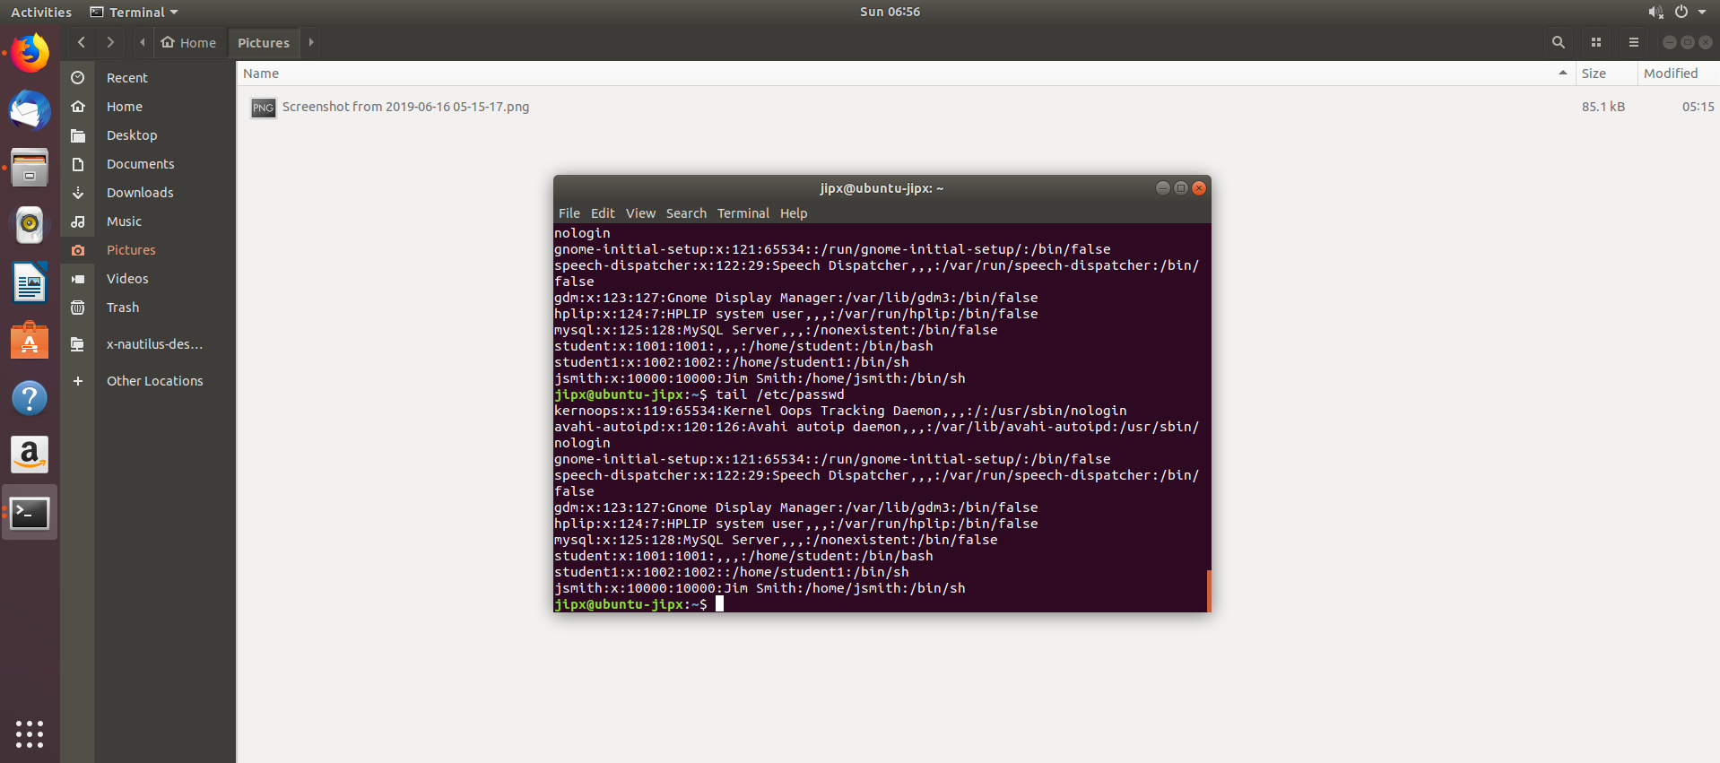

1. After creating a new user it is very important to assign a password to the new account. To set a password for the **jsmith** account enter the following command after the system prompt:  
     
   sudo passwd jsmith
2. The **passwd** command will now prompt you to enter the password you would like to associate with the **jsmith** account.  
     
   Enter the password and press the Enter key when done.
3. The **passwd** command will now prompt you to re-enter the password to ensure that the passwords match.  
     
   Re-enter the password and press the Enter key when done.
4. If all goes well, you will see the following line appear as it does in the screenshot below:  
   passwd: password updated successfully  
   This indicates that the password was successfully changed.  
     
   Congratulations, you have successfully added a new user to your Ubuntu Linux Server system!
5. log in as user jsmith

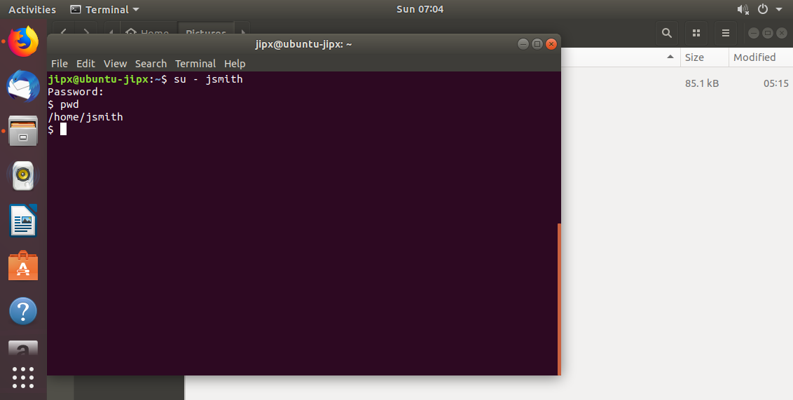

su - switch user

**Verify the user created ( Log out of Jsmith first )**

1. View the contents of the “**/etc/passwd”** and “/**etc/shadow”** file. Note the uid of the user “**jsmith”** and **“root”**.

cat /etc/passwd

sudo cat /etc / shadow

1. As the above command will list all users, the grep command will filter away the extras as shown below:

|  |
| --- |
| sudo grep jsmith /etc/passwd && sudo grep jsmith /etc/shadow |

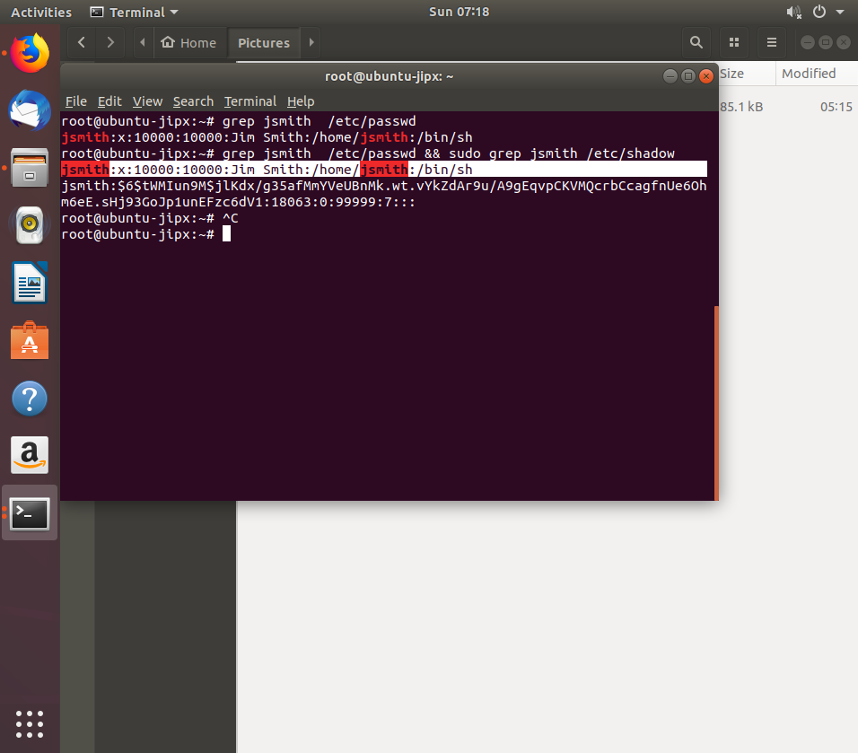

Take note:  
As you can see from the output above, each line has seven fields delimited by colons that contain the following information:

* 1. User name_____jsmith______________
  2. Encrypted password (x means that the password is stored in the /etc/shadow file)________x_____________
  3. User ID number (UID)_______10000_______________
  4. User’s group ID number (GID)_____10000_________
  5. Full name of the user (GECOS)_____________
  6. User home directory_________________Jim Smith______
  7. Login shell (defaults to /bin/bash)____/bin/s____

Type passwd jsmith to change the password for user student to the value of “password”. Use the command from Step 11 (of page 5) to confirm logging in with the new password. Logout for jsmith user.

sudo passwd jsmith to change password without needing to login

1. Type passwd sudo -l jsmith to lock out the user jsmith. (You will notice that you can NEVER login to jsmith by using the password). Try to login using jsmith user and observe the result.

sudo -u jsmith to unlock account

1. Type man 5 shadow to understand what each value in the “**/etc/shadow”** file meant.

## Remove a User

The following steps will guide you through removing an existing user from an Ubuntu Linux Server system.

**IMPORTANT:** Certain ***pre-installed user accounts*** are required for the system to operate properly. Do NOT remove a user from a system unless you are sure the account is not needed!

1. To begin removing a user from your system, you will need to be logged in using a valid user account for your system. If you are unsure of how to do this, read our tutorial on [Logging into Ubuntu Linux Server](https://www.techonthenet.com/linux/sysadmin/ubuntu/login_14_04.php).
2. We will remove the user called **jsmith** along with his home directory and mail spool file by entering the following command:  
     
   sudo userdel -r jsmith  
     
   When you have entered the command, press the Enter key to execute the command.
3. The **sudo** command will now prompt you to enter the password for your administrator account.  
     
   *Please note that no characters will show as you type your password. This is normal and is important to preserve the security of your password.*After you have entered your password, press the Enter key to continue.
4. If all goes well, you will see the system prompt appear again without any errors.

*The* ***userdel*** *command may report that the user's mail spool file was not found. This warning can be ignored and simply means that the* ***userdel*** *command could not remove the user's mail spool file since one did not exist.*

1. In this step we will check to ensure that the user called **jsmith** was removed from the system by using the [grep command](https://www.techonthenet.com/linux/commands/grep.php) to search the system **/etc/passwd** file for the **jsmith** user account. If the user **jsmith** is not found then we will have confirmed that the account has been successfully removed.

Enter the following [grep command](https://www.techonthenet.com/linux/commands/grep.php) after the system prompt to search the system password file:  
  
sudo grep jsmith /etc/passwd  
  
When you have typed the command, press the Enter key to execute the command.

1. As you can observe, the user **jsmith** was not found by the [grep command](https://www.techonthenet.com/linux/commands/grep.php) **Congratulations**, you have successfully removed a user account from your Ubuntu Linux Server system!

## Remove a Group

## The following steps will guide you through removing a group on an Ubuntu Linux Server system.

## IMPORTANT: Certain pre-installed groups are required for the system to operate properly. Do NOT remove a group from a system unless you are sure it is not needed!

## To remove an existing group from your system, you will need to be logged in using a valid user account. If you are unsure of how to do this, read our tutorial on [Logging into Ubuntu Linux Server](https://www.techonthenet.com/linux/sysadmin/ubuntu/login_14_04.php).

## Now that we're logged in, we can remove the group with a Group Name of students by entering the following groupdel command:

## sudo groupdel students typed in the command, press the Enter key to execute the command.

## The sudo command will now prompt you to enter the password for your administrator account. *Please note that no characters will show as you type your password. This is normal and is important to preserve the security of your password.* After you have entered your password, press the Enter key to continue.

## If all goes well, you will see the system prompt appear again without any errors. This indicates that the group called students has been successfully removed.

## In this step we will check to ensure that the group called students was removed from the system by using the [grep command](https://www.techonthenet.com/linux/commands/grep.php) to search the system /etc/group file for the students group. If the students group is not found then we have confirmed that the group has been removed. Enter the following [grep command](https://www.techonthenet.com/linux/commands/grep.php) after the system prompt to search the system group file: sudo grep students /etc/group

## When you have typed the command, press the Enter key to execute the command. The students group was not found by the [grep command](https://www.techonthenet.com/linux/commands/grep.php) confirming that we have removed the students group from the system. Congratulations, you have successfully removed a group from your Ubuntu Linux Server.

Reflection Question:

|  |
| --- |
| Ubuntu, as any other Linux distribution is a multi__user_____ operating system. Each user can have different permission level and specific settings for various command line and GUI application.  In Ubuntu, there are two command-line tools that you can use to create a new user account: useradd and **adduser**.  [useradd](https://linuxize.com/post/how-to-create-users-in-linux-using-the-useradd-command/) is a low-level utility for adding users while the **adduser** a friendly interactive frontend to useradd written in language ___Perl____. **adduser** asks you a series of questions regarding a new account being created, including user's first/last name and account password, and goes ahead creating a home directory of the account |

*End of Practical*